|  |  |  |
| --- | --- | --- |
| |  | | --- | | Merchant’s  Revenge | | |
|  | |
| **Draft 1 2017-09-08** | |
| Software Requirements  Habilou Sanwidi |
| **Specification** |

**Table of Contents**

Table of Contents 2

Game Description 3

MAPS 4

World 4

LEGEND 5

Clourtov 6

Abuthor 7

Monetonc 9

Morestet 10

Lifenour 11

Hackipon 12

Riddles 14

Items 15

Game Description

Once upon a time in the 2nd century, there is a village name Clourtov full of joy and families.

Life in the village was going perfectly great in a normal way. Females or wives help their husband and kid 90% of time accomplishing their duty in the family. One beautiful morning, some strange creature land on the shore of the island with lots of angriness and capture all the kids in the village. After all the trouble the creature cause in the village, she finally disappears with the kids she captures.

The next morning, nothing was left but heart broken families. After few hours, man from the village agree to have a meeting in other to find the best solution and make decisions about how they are going to save their kids life from the Monster. After couple’s days they have decided to send a group of man in villages where the wises man are in other to gain more knowledge and power to save their kids life. Wises man hold information’s about where to go and what to do when monsters attacked villages citizens. During their travel into different villages, they find out that the monster did not only capture kids from their village but from different villages as well.

Now that they understand everything, all man from villages where kids were captured have decide to come together to go fight the strange creature which have magical power with all they must save their kids.

**Matlock**

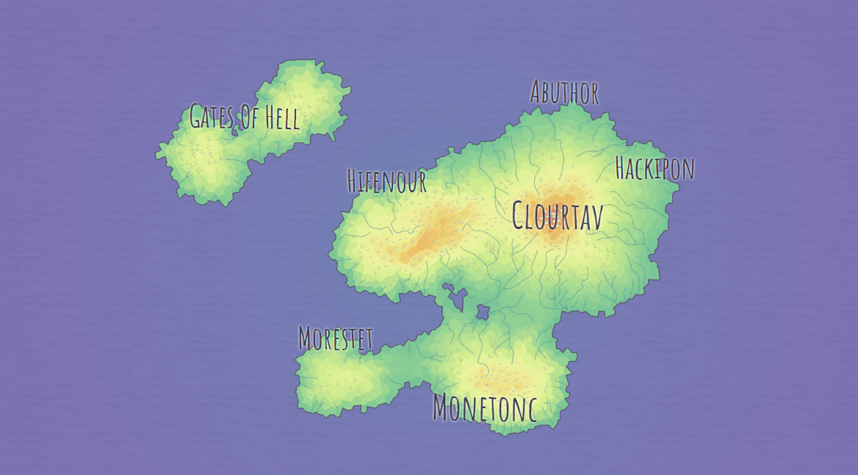

Major Cities of Matlock

* Clourtov
* Hackpin
* Abuthor
* Morestet
* Lifenour
* Monetonc

Legend

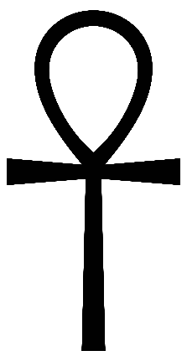

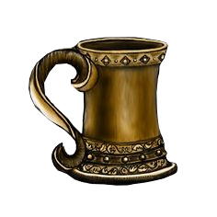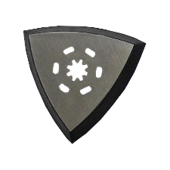

**Castle**

**compass**

**Dungeon**



**Craftsman**

**Riddles**

**Marketplace**

**Tavern**

Clourtov

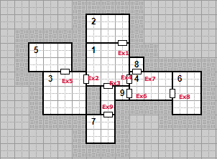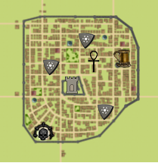

|  |  |  |
| --- | --- | --- |
| Room ID | Description | Exits ID |
| CD1 | You Just descended. In a cramped room with wooden furniture. The only source of light is provided by a burning lamp. | CDx1, CDx2, CDx3, CDx4 |
| CD2 | The room is completely dark. But in the north Est corner, two glittering red eyes are fixated on you | Ex1 |
| CD3 | There are lamps and benches along the wall. On the North wall, stands an iron door, it is a prison. | CDx2, CDx5 |
| CD4 | The room is lit by sunlight from a crack on the ceiling. There are several exist. | CDx4, CDx6, CDx7, CDx8 |
| CD5 | There are claws marks along the walls. Pieces of broken chains on the floor. Looks like this room once was a prison or a torture room. The question is: What kind of monster was held in here. | CDx5 |
| CD6 | The air cold. The stone floor wet. There are dragon fangs next to a dusted furniture by the north-West wall. | CDx8 |
| CD7 | A funky smell is in the air. The only thing you see is a broken chair in the middle of the room. | CDx9 |
| CD8 | The floor has a red carpet. The walls and ceiling are wooden. Towards the south wall, A key lays on brown dusted wooden table. | CDx7 |
| CD9 | This room by far is the smallest. The only thing noticeable is a paint of a old women dressed in a long white cloak. | CDx6 |

**Abuthor**

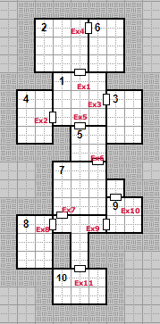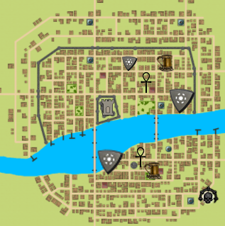

|  |  |  |
| --- | --- | --- |
| Room ID | Description | Exits ID |
| AD1 | The Floor is covered with beach sand. | ADx1, ADx2, ADx3, ADx5 |
| AD2 | This room have a monster called Sheron and a ground on fire | ADx4, ADx1 |
| AD3 | This room is full of multiple dead sea creature heads with oxygen mask | ADx3 |
| AD4 | There is sunlight beaning on a glittered item through a crack along the west wall. | ADx2 |
| AD5 | This room has a wise man sitting down in the middle of the room with a fighting strength potion | ADx5, ADx6 |
| AD6 | This room ceiling is full of multiple color of glass ball with a map | ADx4 |
| AD7 | This room contain blue grass and yellow sky with a cold temperature -100 degree with puzzle | ADx6, ADx7 |
| AD8 | This room atmosphere is 40% dark smoke and a sky full of dark angel with multiple suggestion of different magic weapons | ADx8 |
| AD9 | This room have different music sound bouncing against the wall back and forth with a solid brick walls and ground.  This room have a monster name OMEGA4 | ADx9, ADx10 |
| AD10 | This room have a nice view with a nice shore full of natural blue sea as potion to refiled energy | ADx11 |

**Monetonc**

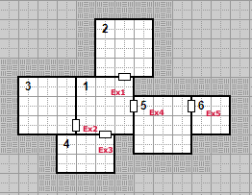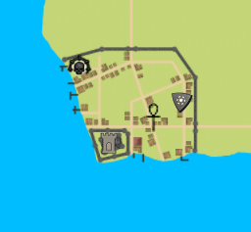

|  |  |  |
| --- | --- | --- |
| Room ID | Description | Exits ID |
| MD1 | You just entered a room with stone walls and floor. The room is lit by lamps. There is a sword high on the west wall. | MDx1, MDx2, MDx3, MDx5 |
| MD2 | This room looks like it once was an armory but now abandoned. There are swords and spears covered on thick layer of dust. | MDx4, MDx1 |
| MD3 | This room has matching furniture. A map lays on a table next to the North wall. | MDx3 |
| MD4 | The first thing you notice is a decomposed armored body with a dusted sword on its right hand. It looks like it’s been sitting here for ages | MDx2 |
| MD5 | The room is empty. The only thing in there is a lamp on the east wall. It looks like a handle for a secret door. | MDx5, MDx6 |
| MD6 | You are face to face with a 10-foot goblin commander. | MDx4 |

**Morestet**

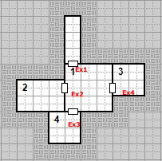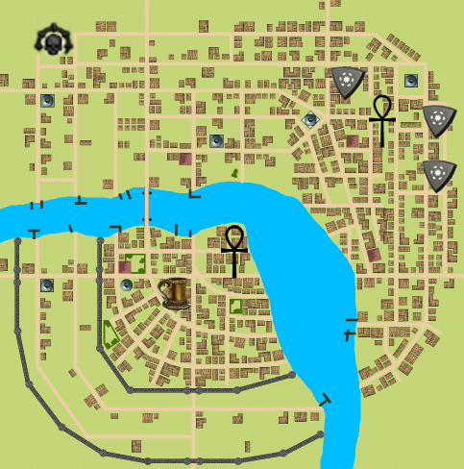

|  |  |  |
| --- | --- | --- |
| Room ID | Description | Exits ID |
| MD1 | You just entered a room with stone walls and floor. The room is lit by lamps. There is a sword high on the west wall. | MDx1, MDx2, MDx3, MDx5 |
| MD2 | This room looks like it once was an armory but now abandoned. There are swords and spears covered on thick layer of dust. | MDx4, MDx1 |
| MD3 | This room has matching furniture. A map lays on a table next to the North wall. | MDx3 |
| MD4 |  | MDx2 |
| MD5 | The room is empty. The only thing in there is a lamp on the east wall. It looks like a handle for a secret door. | MDx5, MDx6 |
| MD6 | You are face to face with a 10-foot goblin commander. | MDx4 |

**Lifenour**

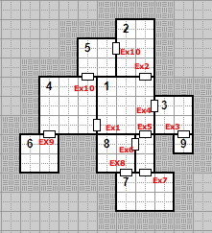

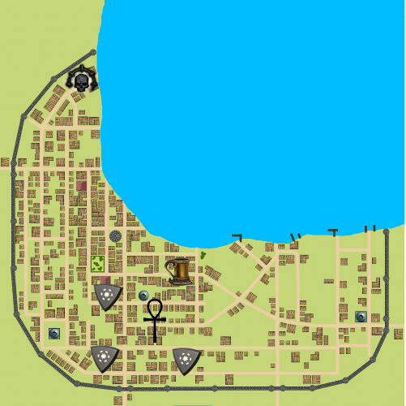

|  |  |  |
| --- | --- | --- |
| Room ID | Description | Exits ID |
| LD1 | This room contain an old couch, and some old art objects.  There are 4 exits on this room. | MDx1, MDx2, MDx3, MDx5 |
| LD2 | This room contain the 1st wise man of all time and his meditation instrument (The big white book) that should lead the player to the next room. | MDx4, MDx1 |
| LD3 | This room have a young musician playing some old music with no stop with a puzzle to solve. | MDx3 |
| LD4 | This room have a dangerous mythical lion chain up so she can’t move. It also has more grass on the ground with a big tree in the middle of the room | MDx2 |
| LD5 | This room is full of trees with different colors and a magic potion that will give the player more energy. This room have two exits. Door 2,4  This room have a red huge water fall which flow at an incredible speed and has a puzzle. | MDx10, MDx11 |
| LD6 | This room temperature is more than 200 degrees because it contains a monster called SUPER SATAN. This room have two exits. Door 8,10  This room have all old ancient graphic representation all over the walls and contain a puzzle to decode the writing. | MDx9 |
| LD7 | This room have old tomb of ancient civilizations with some grass on the floor and a reflection of the sun | LDx7 |
| LD8 | The room is empty. | LDx6, LDx8 |
| LD9 | The room is poison, you must get out as soon as possible or you will die. | LDx3 |

**Hackipon**

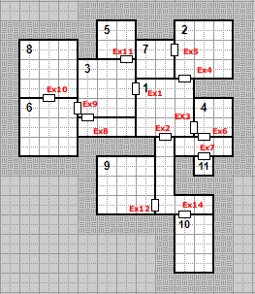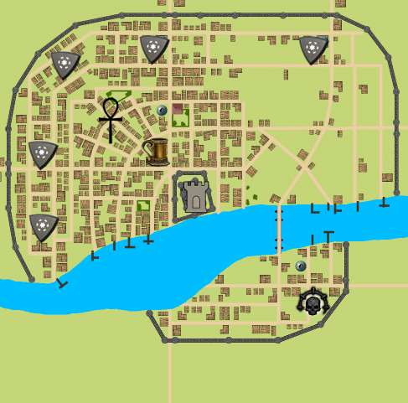

|  |  |  |
| --- | --- | --- |
| Room ID | Description | Exits ID |
| HD1 | This room has no sun light, it is 70% dark and full of Bats as ceiling cover.it also contain some natural free fruits. | HDx1, HDx2, HDx3 |
| HD2 | This room is a shore which contain infinite amount of fish jumping off the lake. | HDx4, HDx5 |
| HD3 | This room contain certain Greek Gods statue from the ancient Greek civilization with some grass around them. This room also contain a puzzle. | HDx1, HD9, HD11 |
| HD4 | This room is full of white eagles with the 2nd wise with answers | HDx3, HDx6 |
| HD5 | This room have some weapon such as arrows and powder gun. | HDx11 |
| HD6 | This room contain a huge Heron monster that can flight at the speed of the light. | HDx9, HDx10 |
| HD7 | This room have a mystery of infinite snow falling and sun up bright at the temperature of 300 degree and contain a green potion that heals wounds | HDx5 |
| HD8 | This room contain more graphic of Greek Gods with a puzzle to solve | HDx10 |
| HD9 | This room have marks of monster fights and a blood everywhere with 90% of black smoke with a puzzle to solve | HDx12 |
| HD10 | This room have some serious magic weapon left behind from monsters | HDx14 |

**Riddles**

|  |  |  |  |
| --- | --- | --- | --- |
| Puzzle ID | Description | Solution | Gain |
| Pz1 | When you need me, you throw me away, but when you're done with me, you bring me back. What am I? | An Anchor | Never take on the Mad Sea without one |
| Pz2 | My first is in attainder but not in nitrate. My second is in stringer but not in ingest.  My third is in population but not in pollution.  My fourth is in doge but not in ode.  My fifth is in sanatorium but not in nasturtium.  My sixth is in clarification but not in factorial. | Dragon | Never kill a baby dragon. |
| Pz3 | I last forever and you might have too much or too little of me, either way you will run out of me eventually. What am I? | Time |  |
| Pz4 | From the trunk of a willow and the scraped hide of a cow I am made. Suffering the fierce savagery of war, I, with my own body, always save my bearer’s body, unless death takes the man’s life. What fierce soldier endures such a fate or receives so many deadly wounds in war? | Shield | The shield of Achilles is hidden somewhere in the city of Abuthor |
| Pz5 | Keep me with you to survive, in the fields of death few keep alive, I am like a taller knife deadly enough to end a live  What am I? | Sword | Only the Excalibur can kill the undead. |
| Pz6 | Multi-colored in hue, I flee the sky and the deep earth. There is no place for me on the ground nor in any part of the poles. No one fears an exile as cruel as mine, but I make the world grow green with my tears. |  | Slime is an extremely slippery substance. |
| Pz7 | What can be swallowed, but can also swallow you, I live in the oceans, the rivers and seas. | Water | Ferocious creatures dwell in the waters of the Mad Sea.  Take this Item, it will be of some use in the battle to come. |
| Pz8 | To go through this gate, you must have the only weapon capable of killing those monsters. I cannot watch another hero die at the end of their swords. |  |  |
| Pz9 | Some try to hide, some try to cheat, but time will show, we always will meet. Try as you might, to guess my name, I promise you’ll know, when you I do claim. Who am I? |  | Death will came for us all but you can go looking for it beyond the Gates of Hell. |
| Pz10 | It walks on four legs in the morning, two legs at noon and three legs in the evening. What is it? | Man |  |
| Pz11 | At night they come without being fetched. By day they are lost without being stolen. What are they? | Stars |  |

**Items**

|  |  |  |  |  |
| --- | --- | --- | --- | --- |
| ID | Name | Description | Price | Shop/Armory |
| It1 | Potion | Heals the player 20 health | 100G | Shop |
| it2 | Bomb | Deals 10 damage. Only one per battle. | 150G | Shop |
| it3 | Sight Potion | Gives a +10% Accuracy bonus for battle (Not stackable) | 500G | Shop |
| IT4 | Power Potion | Gives a +5 Damage bonus for battle (Not stackable) | 500G | Shop |
| IT5 | Def Potion | Gives a +5 Defense Bonus for battle (Not stackable) | 750G | Shop |
| it6 | Arcane potion | Powerful Magic that is unleashed on foes. Deals 15 damage | 1000G | Shop |
| it7 | Smoke Bomb | Guarantees you can run away. (Doesn't work on bosses) | 50G | Shop |
| It8 | Poison Dart | Throw to poison your foes. (Does not work on undead, ghouls, or bosses) | 75G | Shop |
| It9 | Ghost Tears | Grants +10% evasion making foes more likely to miss. (Not stackable) | 500G | Shop |
|  |  |  |  |  |
| it10 | Knife | 2p with 85% accuracy | 50G | Armory |
| it11 | Sword | 5p with 70% accuracy | 150G | Armory |
| it12 | Hammer | 8p with 50% accuracy | 200G | Armory |
| It13 | Long Sword | 7p with 65% accuracy | 225G | Armory |
| it14 | Brass Knukles | 5p with 55% accuracy. Can attack twice. | 225G | Armory |
| it15 | Gunblade | 12p with 30% accuracy | 250G | Armory |
| it16 | Great Sword | 10p with 60% accuracy | 325G | Armory |
| it17 | Haleberd | 13p with 50% accuracy | 350G | Armroy |
| it18 | Mighty Axe | 12p with 60% accuracy | 375G | Armory |
| it19 | Boi Staff | 9p with 85% accuracy | 375G | Armory |
| it20 | Lance | 10p with 75% accuracy | 425G | Armory |
| it21 | Knight's Blade | 15p with 80% accuracy | 500G | Armory |
| it22 | Leather Clothes | Grants 2 DEF | 75G | Armory |
| it23 | Iron Plating | Grants 3 DEF | 125G | Armory |
| it24 | Steel Armor | Grants 5 DEF | 750G | Armory |
| it25 | Stealth Cloak | Grants +30% evasion | 750G | Armory |
|  |  |  |  |  |
| it26 | Club | 6p with 65% accuracy | N/A | N/A |
| It27 | Spear | 3p with 80% accuracy | N/A | N/A |
| It28 | Mace | 8p with 60% accuracy | N/A | N/A |
| It29 | Twin Blades | 5p with 65% accuracy | N/A | N/A |
| It30 | Staff | 4p with 55% accuracy | N/A | N/A |
| It31 | Mighty Spear | 8p with 70% accuracy | N/A | N/A |
| It32 | Spiked Club | 18p with 40% accuracy | N/A | N/A |
|  |  |  |  |  |
| It33 | Crown | Sold for 1000 gold | N/A | N/A |
| It34 | Slime | Slippery substance that could have some uses. | N/A | N/A |
| It35 | Batwings | Can be used in trades | N/A | N/A |
| It36 | Dragon Egg Piece | Can be used in trades | N/A | N/A |
| It37 | Dragon Scales | Can be used in trades | N/A | N/A |
| It38 | Ham | Heals the player 10 health | N/A | N/A |
| It39 | Steel Fangs | Can be used in trades | N/A | N/A |
| It40 | Poison | Makes next attack poisonous in battle | N/A | N/A |
| It41 | Web | Makes opponent lose 2 turns. (Once per battle. Doesn't work on Hmong or bosses) | N/A | N/A |
| It42 | Quest Item | Used to proceed in the adventure | N/A | N/A |
| It43 | Red Slime | Makes next attack steal life equal to damage dealt. (Not stackable) | N/A | N/A |